|  |  |  |  |
| --- | --- | --- | --- |
|  | Bansilal Ramnath Agarwal Charitable Trust's  Vishwakarma Institute of Information Technology  Department of  Artificial Intelligence and Data Science | | |
| Name: Siddhesh Dilip Khairnar | | | |
| Class: SY-B tech | Division: B | | Roll No: 272028 |
| Semester: 3rd | | Academic Year:2022-2023 | |
| Subject Name & Code: ES21201AD: Discrete Mathematics | | | |
| Title of Assignment: program to calculate no of nodes, depth and height, no of nodes. | | | |
| Date of Performance: 28/11/2022 | | Date of Submission: 05/12/2022 | |

Problem Statement: Program to calculate no of nodes, depth and height, no of nodes at level n for binary tree.

Introduction to Tree Data Structure: This data structure is a specialized method to organize and store data in the computer to be used more effectively. It consists of a central node, structural nodes, and sub-nodes, which are connected via edges. We can also say that tree data structure has roots, branches, and leaves connected with one another.

The data in a tree are not stored in a sequential manner i.e., they are not stored linearly. Instead, they are arranged on multiple levels or we can say it is a hierarchical structure. For this reason, the tree is considered to be a non-linear data structure.

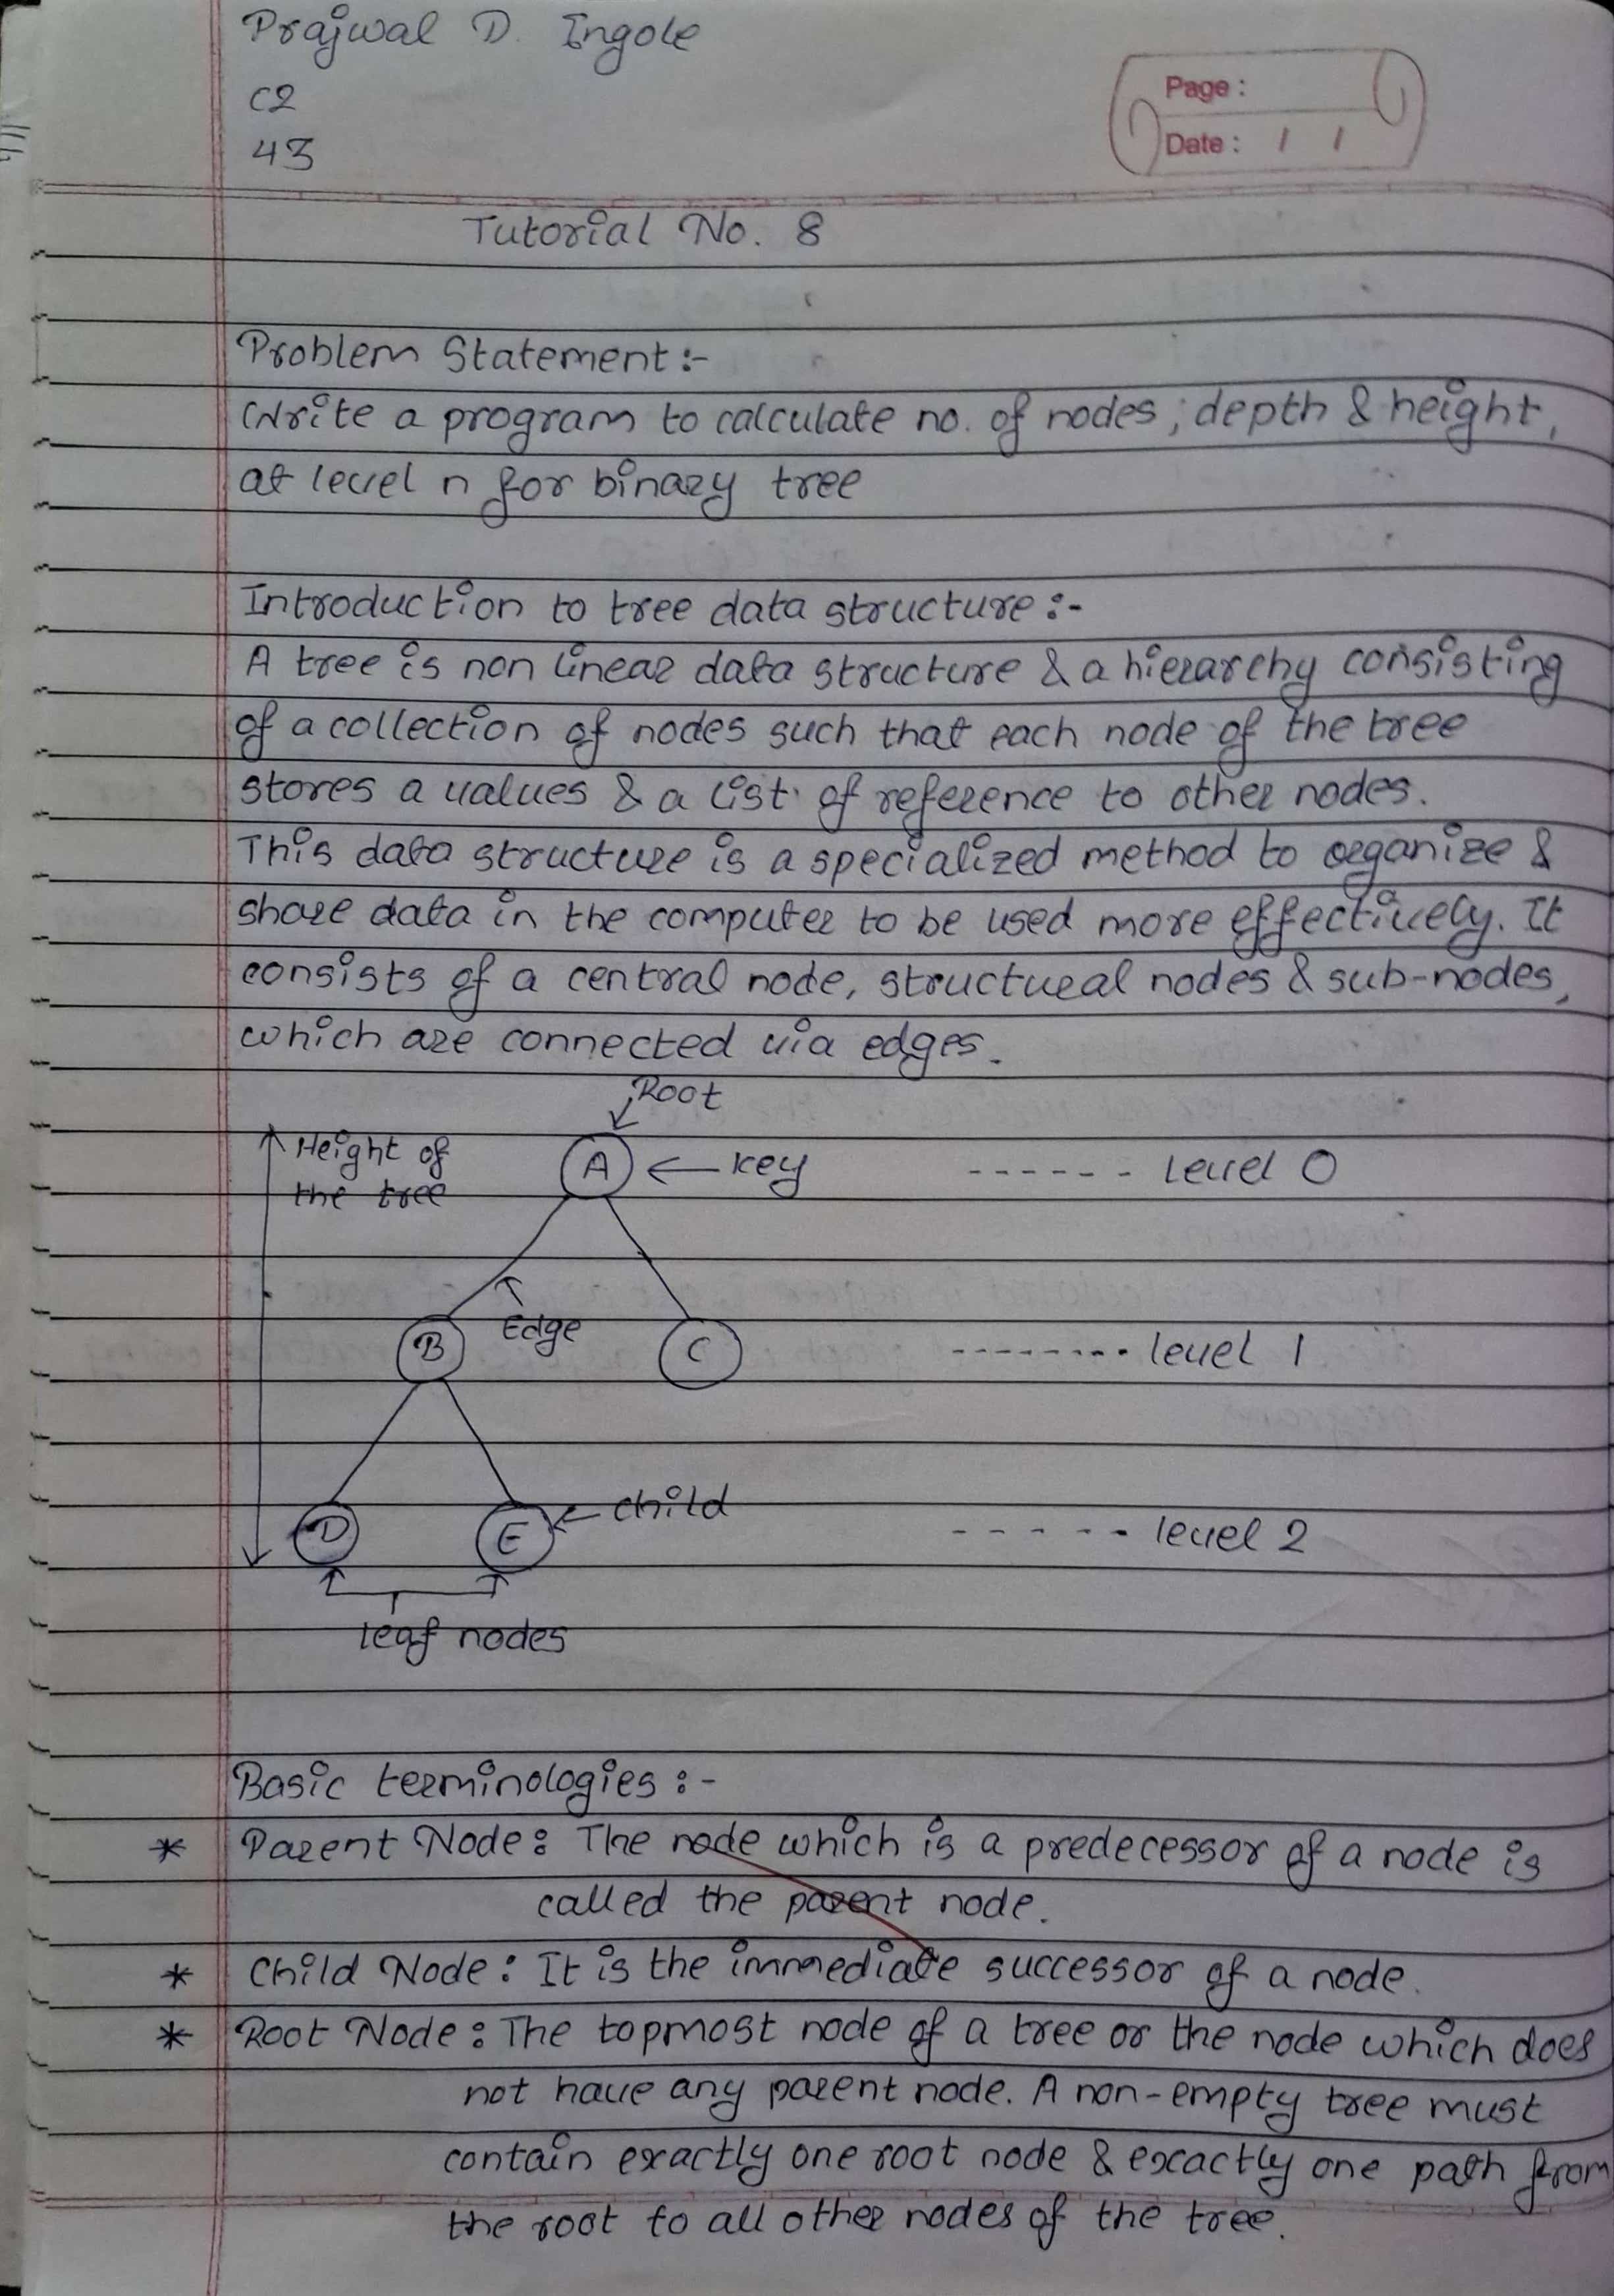

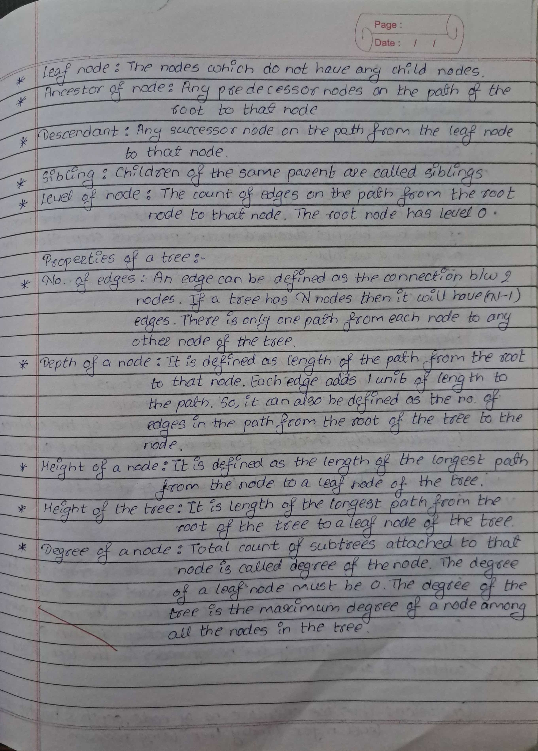

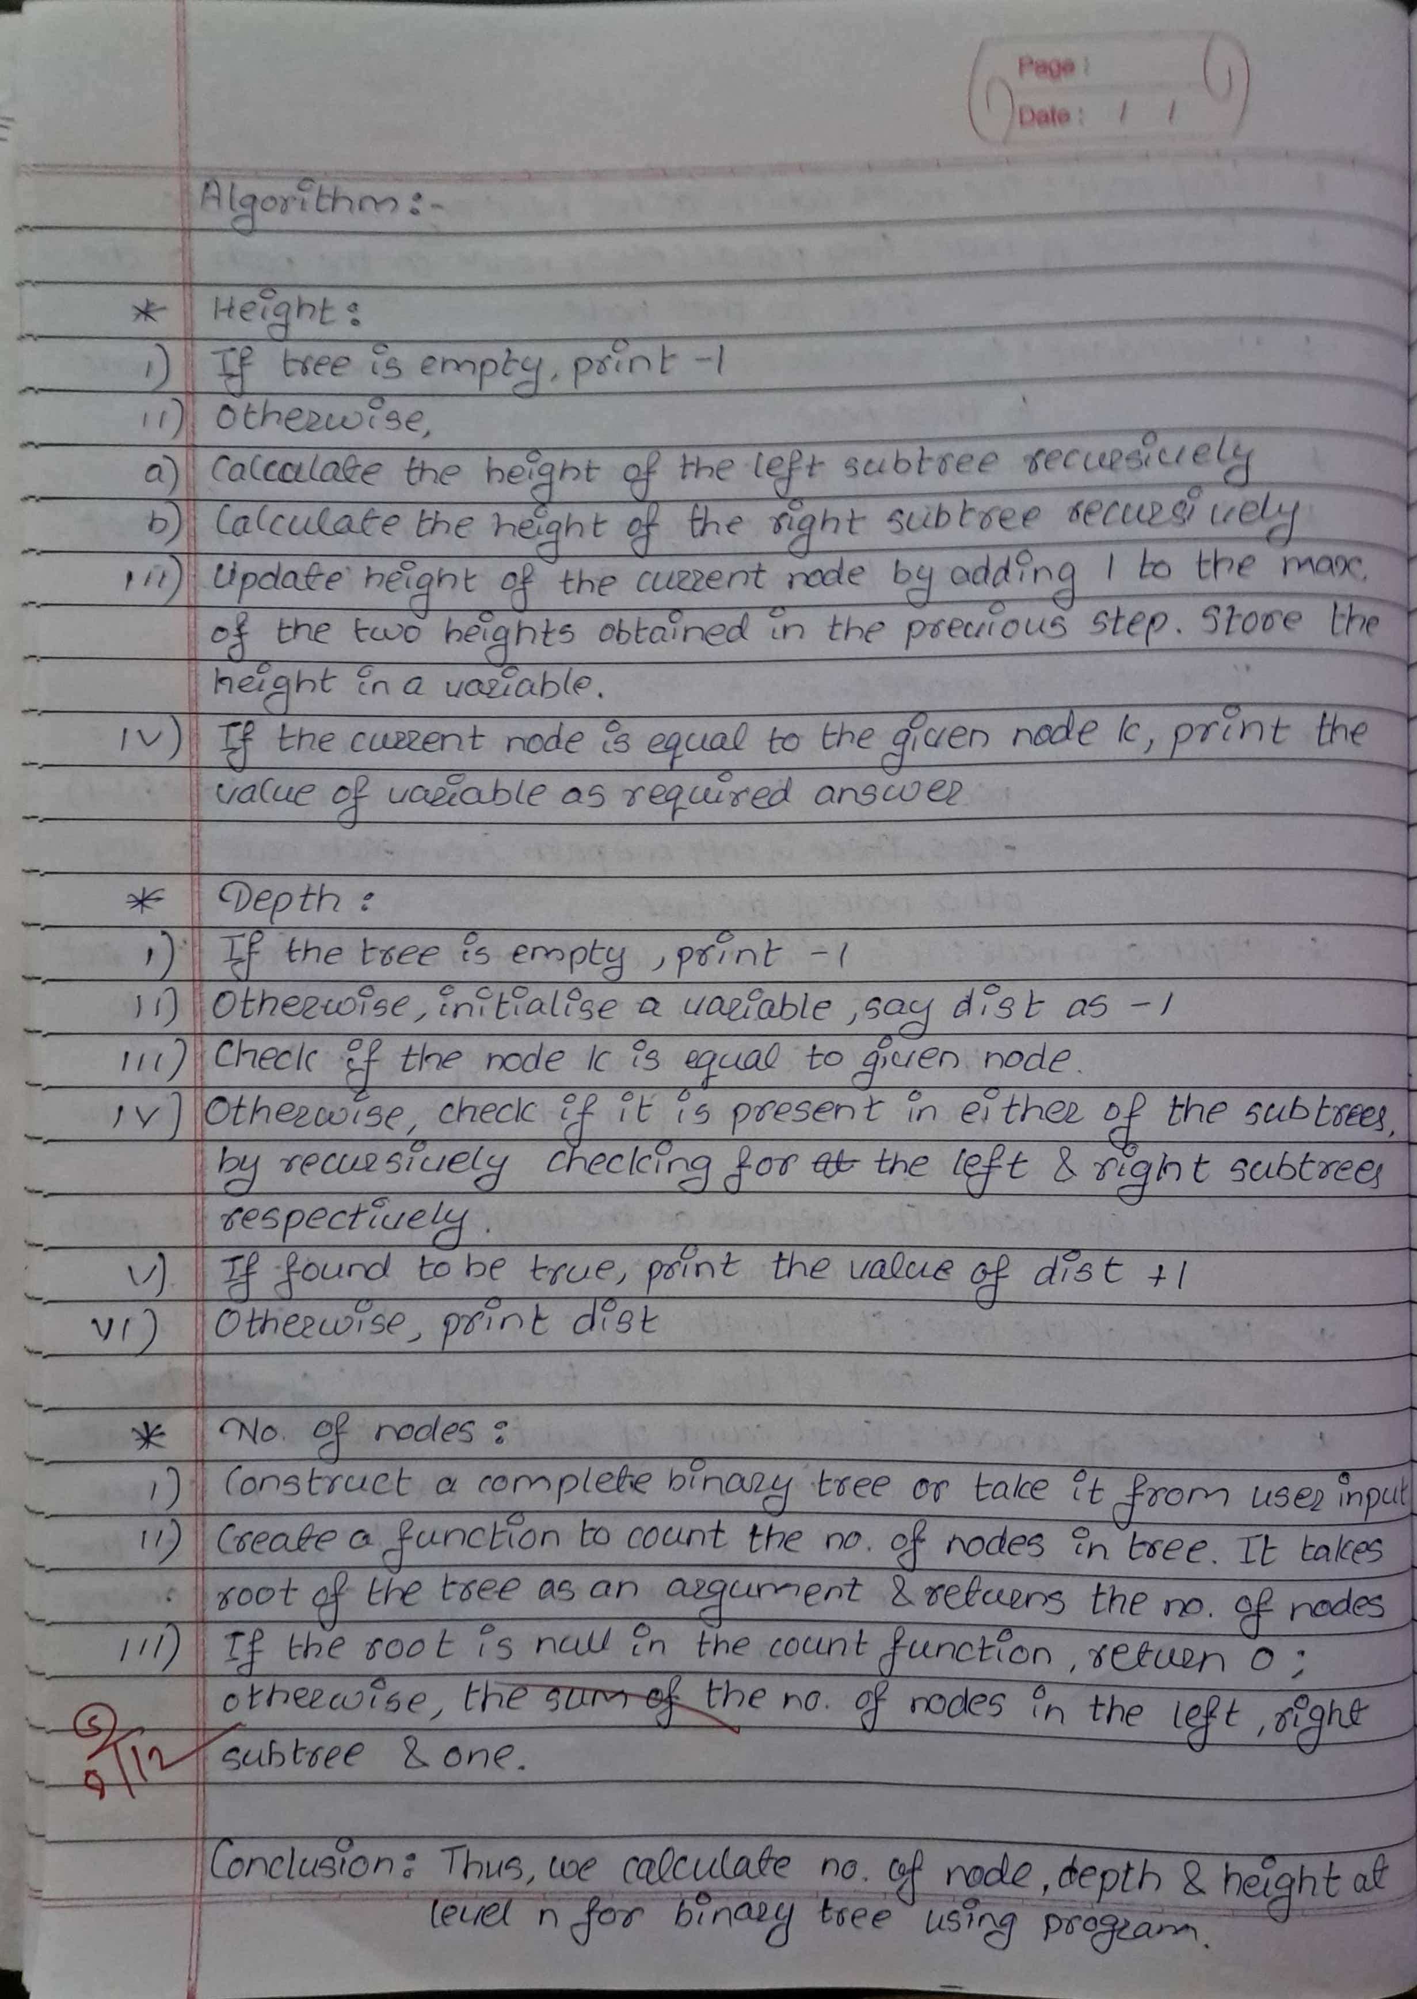

Program Input:

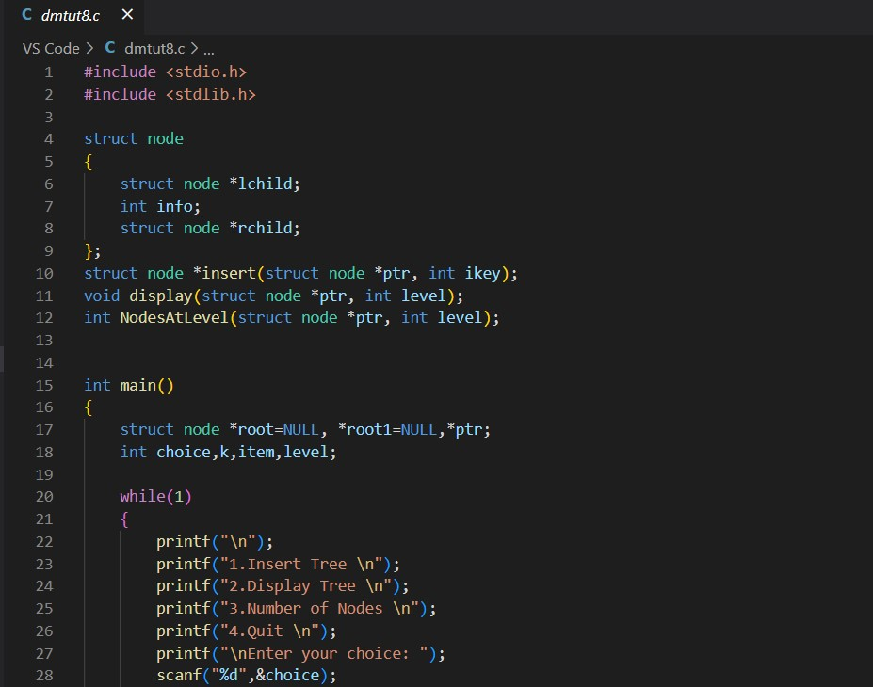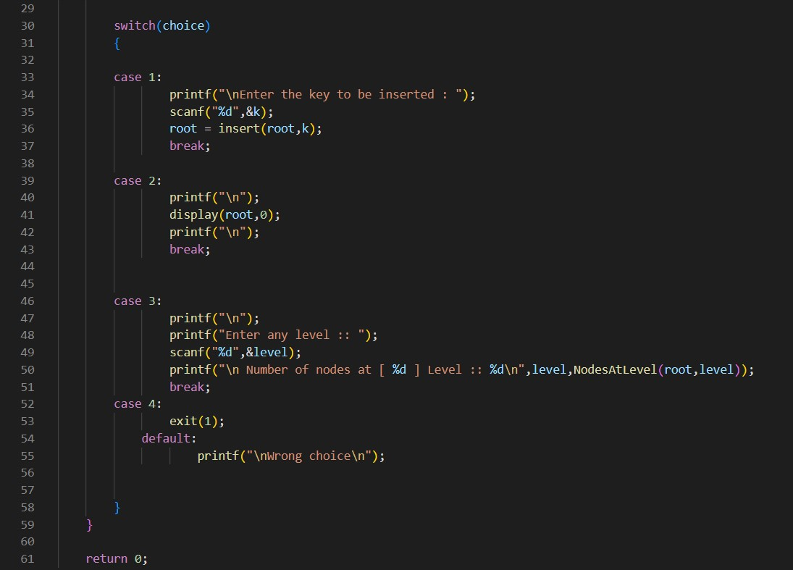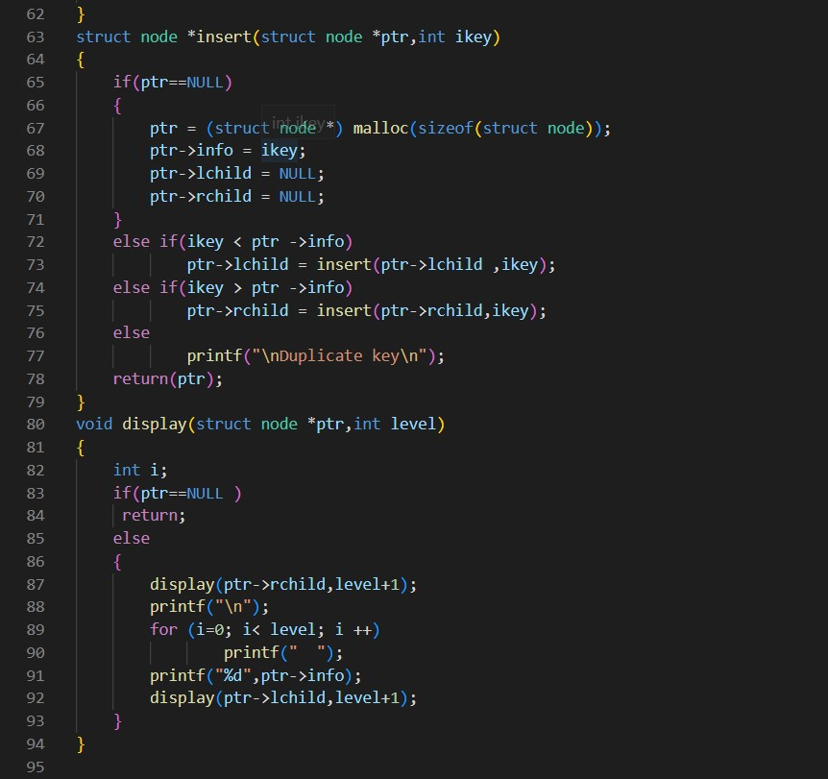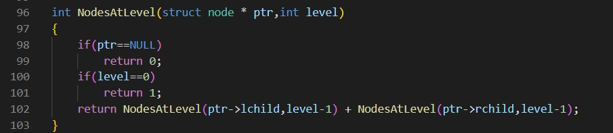

Program Output:

